LAKSHIT TYAGI
Python & Bash
1. Grade Checker
Take a score as input and print the grade based on the following:
- 90+ : “A”
- 80–89 : “B”
- 70–79 : “C”
- 60–69 : “D”
- Below 60 : “F”
- Use a basic if / else statement to determine the grade.
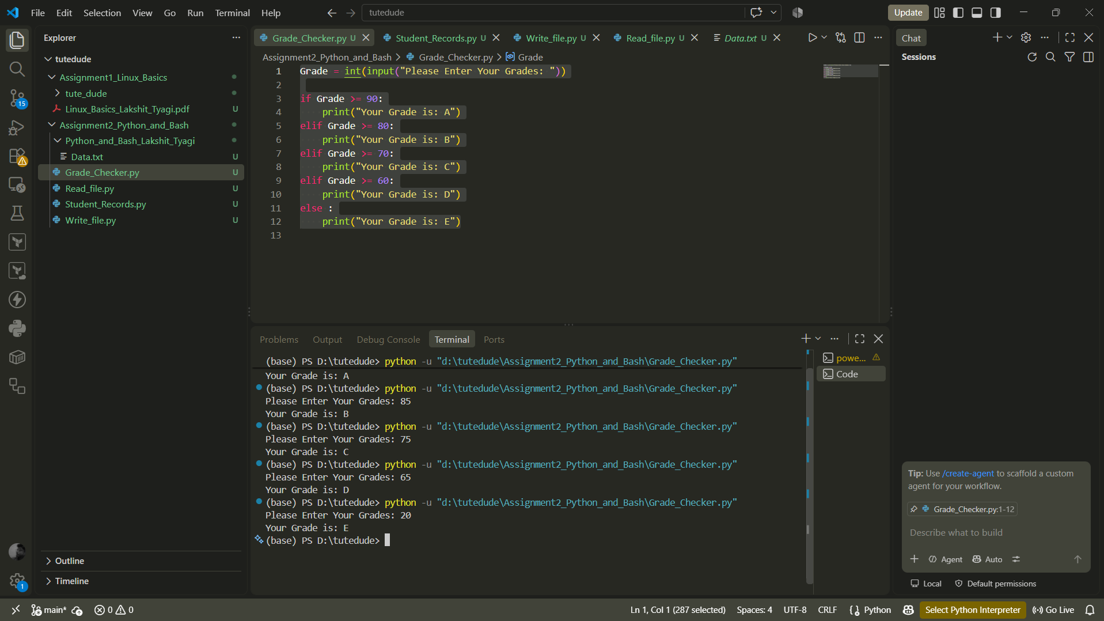

Code:
Grade = int(input("Please Enter Your Grades: "))

if Grade >= 90:
print("Your Grade is: A")
elif Grade >= 80:
print("Your Grade is: B")
elif Grade >= 70:
print("Your Grade is: C")
elif Grade >= 60:
print("Your Grade is: D")
else :
print("Your Grade is: E")

2. Student Grades
Create a dictionary where the keys are student names and the values are their grades. Allow the user to:
- Add a new student and grade.
- Update an existing student's grade.
- Print all student grades.
- Use a dictionary and basic operations with if / else.
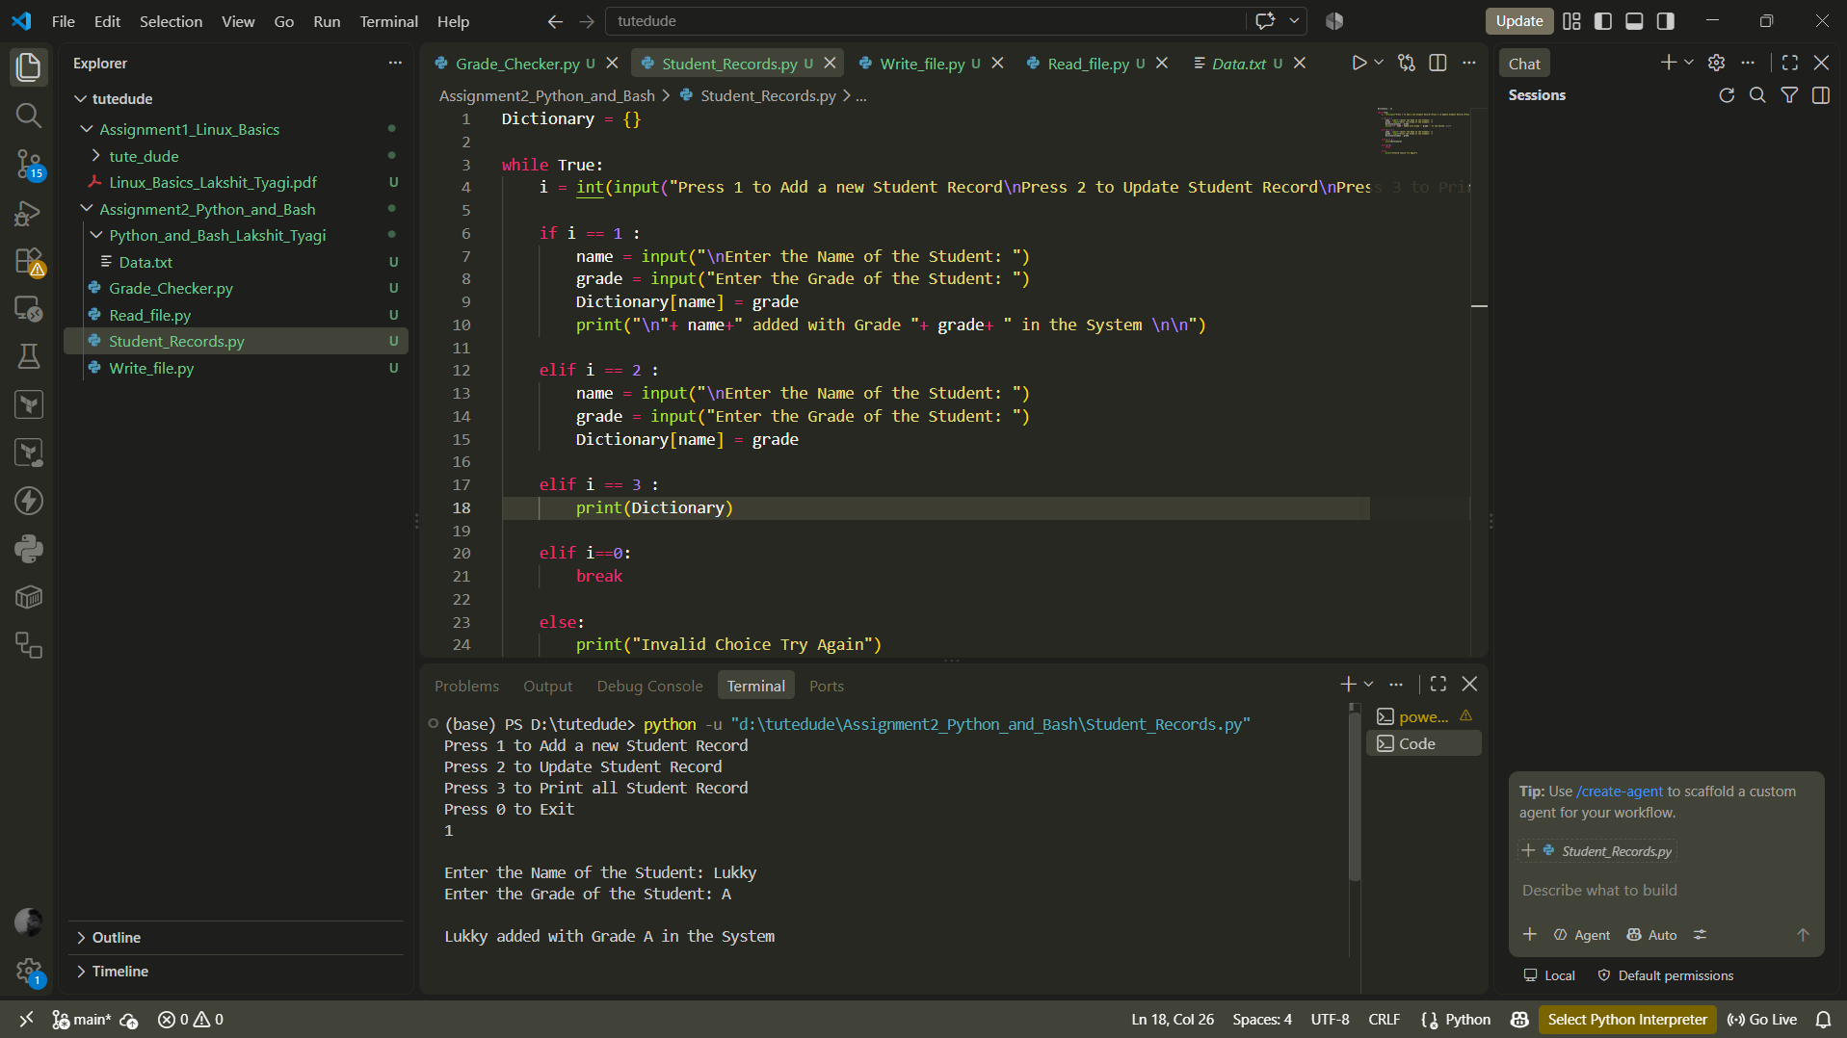
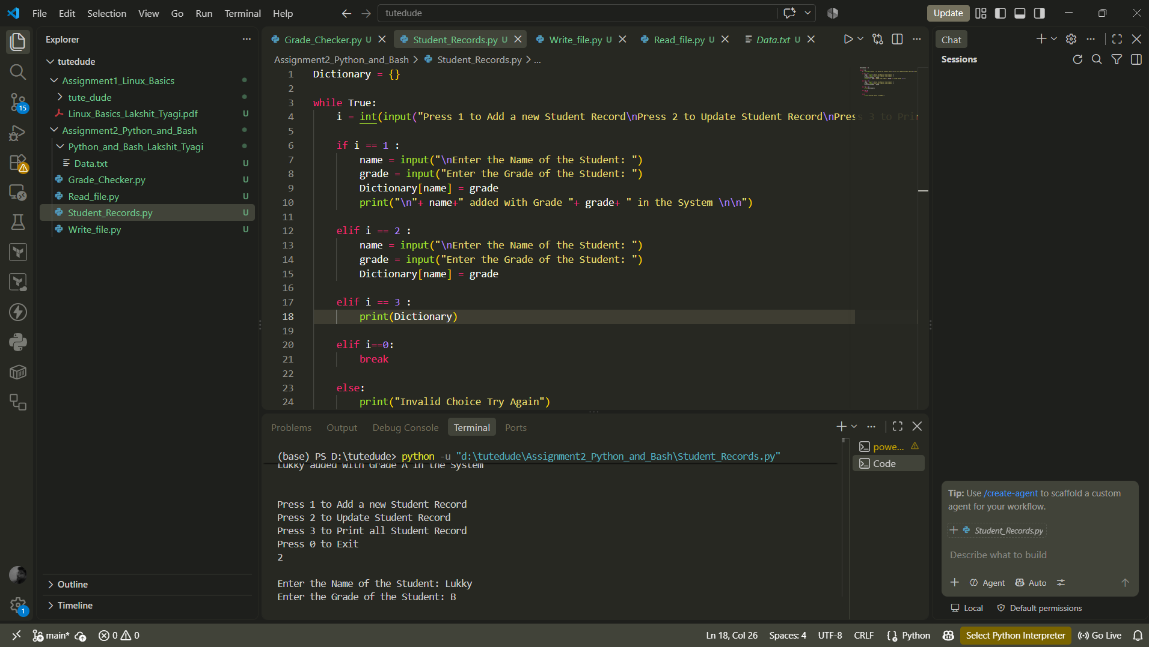
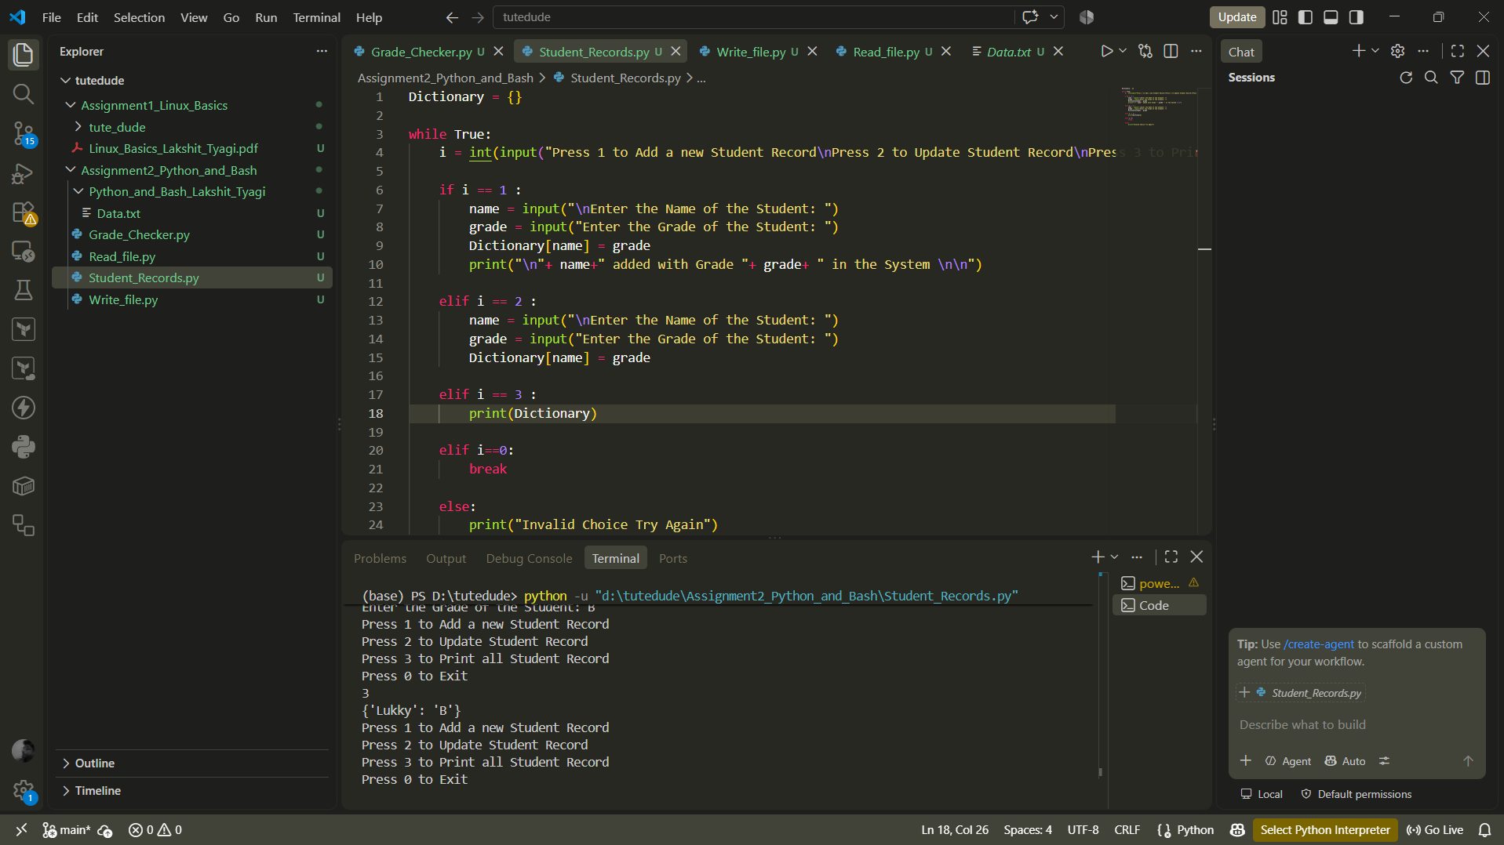

Code
Dictionary = {}

while True:
i = int(input("Press 1 to Add a new Student Record\nPress 2 to Update Student Record\nPress 3 to Print all Student Record\nPress 0 to Exit\n"))

if i == 1 :
name = input("\nEnter the Name of the Student: ")
grade = input("Enter the Grade of the Student: ")
Dictionary[name] = grade
print("\n"+ name+" added with Grade "+ grade+ " in the System \n\n")

elif i == 2 :
name = input("\nEnter the Name of the Student: ")
grade = input("Enter the Grade of the Student: ")
Dictionary[name] = grade

elif i == 3 :
print(Dictionary)

elif i==0:
break

else:
print("Invalid Choice Try Again")

3. Write to a File
- Write a program to create a text file and write some content to it, using file functions like open() and write().
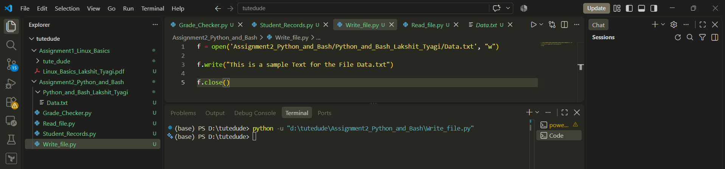
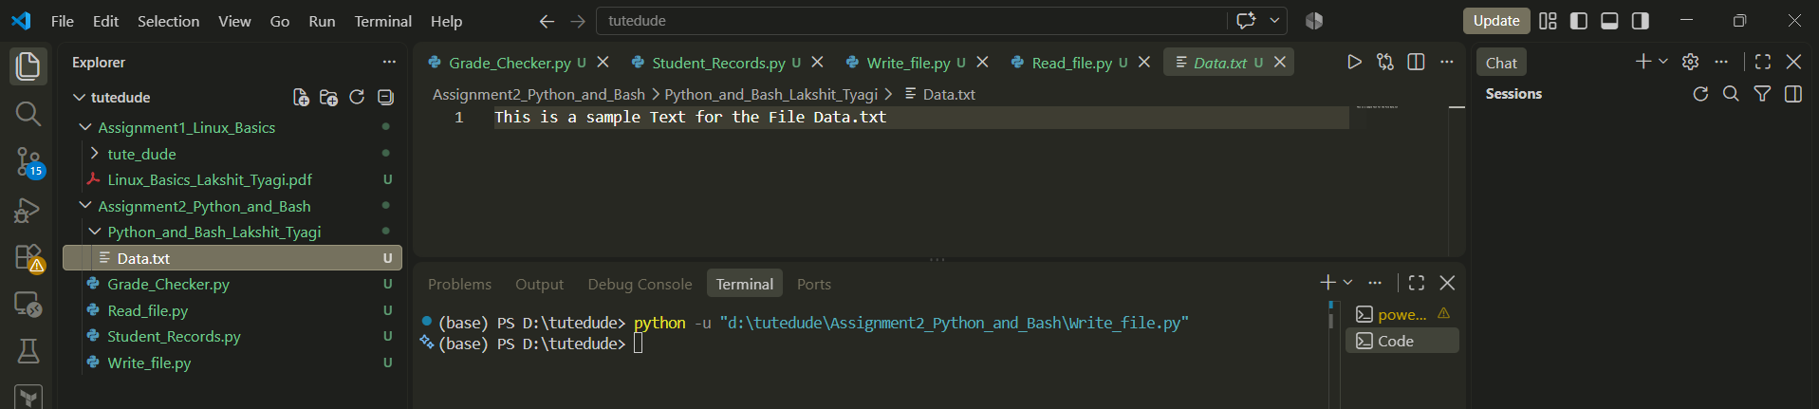
Code:
f = open('Assignment2_Python_and_Bash/Python_and_Bash_Lakshit_Tyagi/Data.txt', "w")

f.write("This is a sample Text for the File Data.txt")

f.close()

4. Read from a File
- Open the file in read mode and use file.read() to read and display its content.
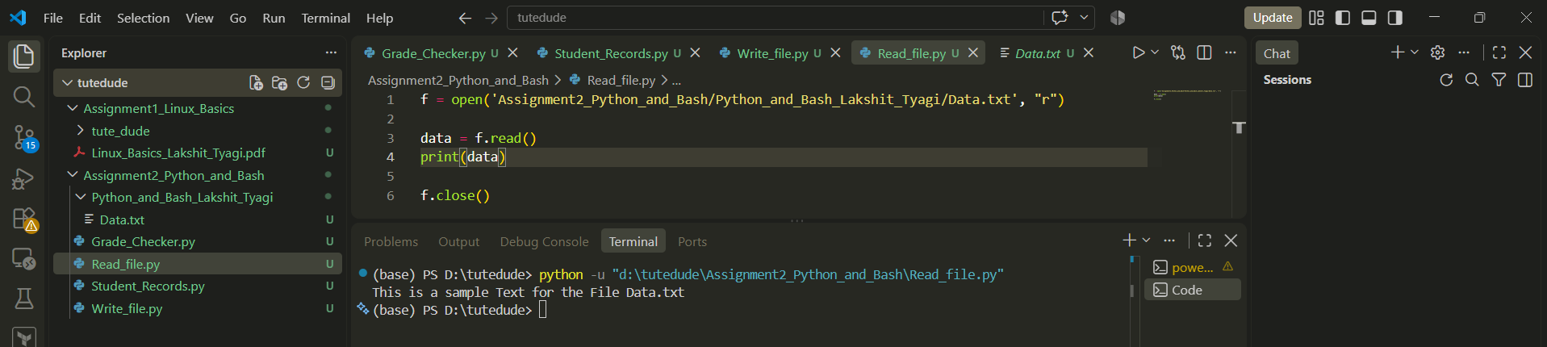

Code:
f = open('Assignment2_Python_and_Bash/Python_and_Bash_Lakshit_Tyagi/Data.txt', "r")

data = f.read()
print(data)

f.close()

Calculator
Code:
# Add Numbers
def add(a, b):
return a + b

# Subtract Numbers
def subtract(a, b):
return a - b

# Multiply Numbers
def multiply(a, b):
return a * b

# Divide Numbers
def divide(a, b):
try:
return a / b
except ZeroDivisionError:
return "Cannot Divide by Zero"

# Infinite Loop
while True:

print("\n1. Add Numbers")
print("2. Subtract Numbers")
print("3. Multiply Numbers")
print("4. Divide Numbers")
print("0. Exit Calculator")

i = int(input("Enter your choice for Operation: "))

if i == 0:
break

a = int(input("Enter the First Number: "))
b = int(input("Enter the Second Number: "))

if i == 1:
print("Your Result is:", add(a, b))

elif i == 2:
print("Your Result is:", subtract(a, b))

elif i == 3:
print("Your Result is:", multiply(a, b))

elif i == 4:
print("Your Result is:", divide(a, b))

else:
print("Invalid Input, Try Again")

